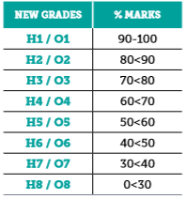 | 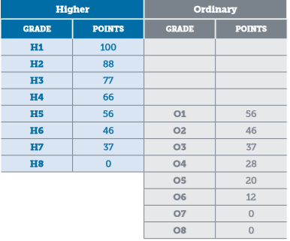
- Files
Read a text file which contains 7 grades. Calculate the total points and append this total to the original file. Don’t worry about Higher or Ordinary level here but use the points for Higher.

- Foreach Loop
If you have not already done so make use of a foreach loop in the previous exercise

- Array
Create two arrays which hold the grade boundaries and higher level point. The grade boundaries are the marks that are on the boundary between two grades such as 90, 80, 70 etc. Amend the program so that it makes use of the arrays in calculating points. This program should read from a file but should output total points to the screen and not amend the file.

- Methods. Create a method which accepts an array of grades (assume higher level only) and calculates the points.

- Write a program which takes user input and asks for Name, Student Number, Subjects, Level and Grade and displays a tabulated report to screen and writes this to file with all the all the inputs and the points total. Assume 7 subjects.

- Create a new object-oriented program with several classes. You decide what the classes are. The program should ask the user to enter name and student number. Then ask how many subjects the student has results for. It should ask for subject name, percentage and level for each of these subjects. The program should determine the grade (H1/O1 etc) and points and produce a tabulated report of subjects, grades and points with a total for points. This report should also be saved as a text file.

